**1.**

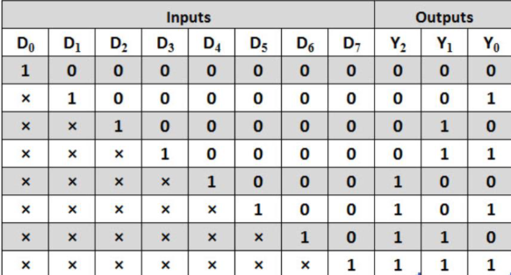

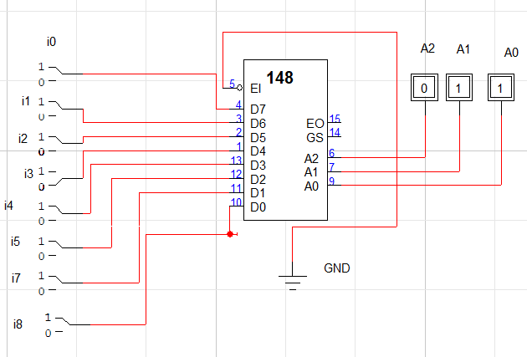

2.

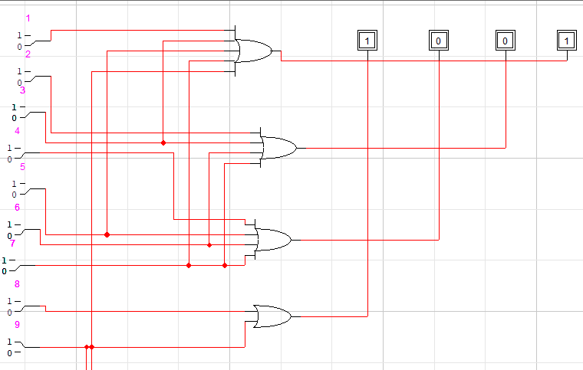

**3.**

